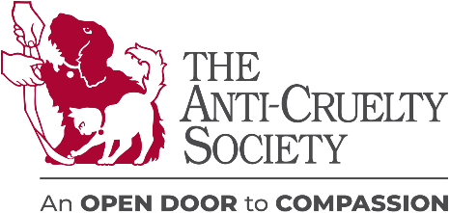
Veterinary Ambassador Program Agreement

This agreement will be in effect for a period of one (1) year from the date signed unless one or both parties agree to terminate for cause before that date. Notification must be given in writing.

As a Veterinary Ambassador, you are entitled to the following benefits:
- Listing as a Veterinary Ambassador in our ASC Magazine and Annual Report, circulation of 30,000 households
- Your vet practice highlighted in adoption packets and on our website exposing your clinic to thousands of potential new clients to help grow your business
- Continued education, seminars, and networking opportunities for veterinarians, vet techs, managers, and staff
- Additional opportunities to partner with us during community outreach initiatives and ACS events
- Inclusion and mention in Vet Ambassador society media post(s)
Veterinary Ambassador Requirements:
- Offer a wellness examination for $20. The wellness exam will be limited to a one-time visit within 90 days of the date of the pet’s adoption from ACS. The wellness exam must include a physical examination.
- Any/all tests, vaccinations, and/or procedures recommended through the wellness examination, will be provided at a 5% discount.
- Display an ASC Veterinary Ambassador certificate, provided by us, prominently in your lobby
- Provide a financial commitment of $500 annually to ACS

Thank you for partnering with The Anti-Cruelty Society and helping with our commitment to providing the BEST care for all animals and people in our communities. In partnership, we can achieve our mission to build a healthy and happy community where pets and people thrive together and build a humane Chicago.
___________________________________________ _______________________________
Name of Veterinary Clinic or Hospital Best Contact Email

_____________________________________________ _________________________________
Printed Name of Veterinary Ambassador Representative Telephone

_____________________________________________ ______________________
Signature of Veterinary Ambassador Representative Date

_______________________________________________
Printed Name of The Anti-Cruelty Society Representative
_______________________________________________ ______________________
Signature of The Anti-Cruelty Society Representative Date

